We kindly ask you to fill in this application form in its entirety and return. Partial or non-coherent information may cause the issue of a wrong quotation and a subsequent re-evaluation.

# COMPANY INFORMATION (mandatory fields)

Company name

Registered office address ________________________________________________________________________ no. _____

ZIP code ___________ City _______________________________________________________ Country _________________

Operating office address _________________________________________________________________________ no. _____

ZIP code ___________ City _______________________________________________________ Country _________________

Telephone________________________ Fax _________________________ E-mail ___________________________________

Contact Person ____________________________________________________Work position _________________________

Shipping address for documentation (reports, certificates etc.):

Address _____________________________no. ____ ZIP code ________ City _____________________ Country __________

Contact person ______________________________________Mail________________________________________________

# CERTIFICATION DIRECTIVES/REGULATIONS THE COMPANY IS APPLYING FOR (mandatory data)

BED CE  BED UKCA  BED UKNI

GAR CE  GAR UKCA  GAR UKNI

See Appendix A for nomenclature

# CERTIFICATION MODULES THE COMPANY IS APPLYING FOR (mandatory data only in case of issue/update of technical file relative to Dir. 92/42/CEE and Reg. (EU) 2016/426)

Type Examination Annex III module “B“

Product Verification Annex III, par. 5 module “F”

Unit Verification Annex III, par. 5 module “G”

# REQUEST DETAILS:

Test report:  New  Update of report no. ________________________________________

Type of appliance/fitting: ___________________________________________________________________________________

(eg. condensing boiler, air heaters, built-in hob for domestic use, burner control, gas valve, …)

Models name to certify:

Trade mark:

Standard: Voltage supply: ________________________________

Short description of the activity: ___________________________________________________________________________

Type of activity:  New appliances/fittings

Extension to other trademarks

Normative update

Update of existing appliances/fittings (components, gas groups, etc.)

If testing is required, go to Appendix B

Surveillance:  New surveillance agreement with Kiwa

Update surveillance agreement with Kiwa

If applicable – existing Kiwa Contract Number: ……………..

Combustion and safety tests performed at:  Lab. Kiwa  Lab. Manufacturer  Other ________________­­­­____________

Electrical safety tests performed at:  Lab. Kiwa  Lab. Manufacturer  Other ________________­­­­____________

EMC tests performed at:  Lab. Kiwa  Lab. Manufacturer  Other ________________­­­­____________

Additional requested declaration:

ERP LABELING  _________________

Private Labeller list to whom issue the certificate/es requested with this application form:

|  |  |
| --- | --- |
| Private Labeller* | Address |
|  |  |
|  |  |
|  |  |
|  |  |
|  |  |
|  |  |

*Private Labeller: It is a company that place on the market under his company name or trade mark products manufactured by a third party. Private Labeller must issue a mandate to the manufacturer to be responsible for Type Approval and Surveillance.

# TECHNICAL INFO (mandatory fields):

Declared IP degree: __________________________________ (eg. IPX4D, IP5, …)

Appliance equipped with burner control?  Yes  No

Appliance equipped with non-CE/UKCA/UKNI certified fitting?  Yes  No

“Range Rated” appliance? (only for boiler):  Yes  No

Other:_______________

Requested gas groups:

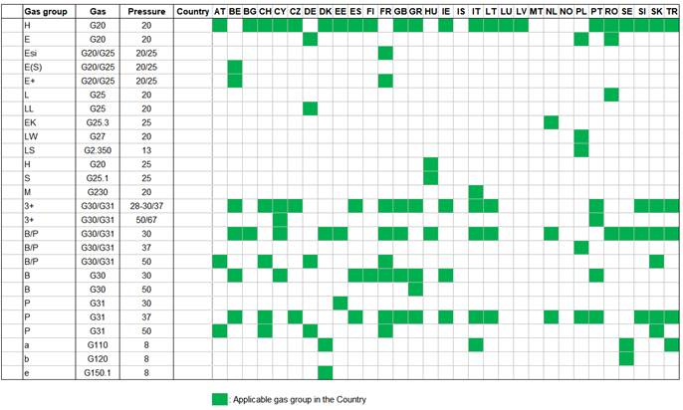

Requested Appliance types:

|  |  |  |  |  |
| --- | --- | --- | --- | --- |
| A1 | B11 | C11 | C12 | C13 |
| A2 | B11BS | C21 | C22 | C23 |
| A3 | B22 | C31 | C32 | C33 |
|  | B22P | C41 | C42 | C43 |
|  | B23 | C51 | C52 | C53 |
|  | B23P | C61 | C62 | C63 |
|  | B32 | C71 | C72 | C73 |
|  | B33 | C81 | C82 | C83 |
|  | B53 | C91 | C92 | C93 |
|  |  |  | C10 |  |
|  |  |  | C11 |  |

# DOCUMENTATION NECESSARY TO ISSUE THE QUOTATION (mandatory data – to be attached)

* List of appliances divided into their reference families

The CE Certificate service may be delivered by the following Kiwa location:

Kiwa NL - Wilmersdorf, 50 (PO Box 137, 7300 AC), 7327 AC APELDOORN

Kiwa IT - Via Cadriano, 23, 40057 - Cadriano di Granarolo (BO)

The UKCA and UKNI service will be delivered by the following location:

Kiwa UK - Kiwa House, Malvern View Business Park, Stella Way, Bishops Cleeve, Cheltenham, Gloucestershire, GL52 7DQ

Date **________________**

Stamp and signature of the Representative of the Company (by consensus) …….………………………………………………..……….

**Appendix A**

BED CE - Directive 92/42/EEC

GAR CE - Regulation (EU) 2016/426

BED UKCA - Ecodesign for Energy-Related Products Regulations 2010, SI 2010 No. 2617, as amended

GAR UKCA - Gas Appliances Regulation (Regulation (EU) 2016/426 as brought into GB law and amended), and the Gas Appliances (Enforcement) and Miscellaneous Amendment Regulations 2018 No 389

BED UKNI - Boiler Efficiency Directive (92/42/EEC) as amended

GAR UKNI - Gas Appliances Regulation (Regulation (EU) 2016/426) implemented in Northern Ireland by the Gas Appliances (Enforcement) and Miscellaneous Amendment Regulations 2018

LVD - LVD (2014/35/ EU)

Machinery Directive - Machinery Directive (2006/42/CE)

RED - RED (2014/53/ EU)

EMC - EMC (2014/30/EU)

**Appendix B**

Type of test:  Combustion and safety tests

Electrical safety (EN 60335-1 + EN 60335-2-102):

Minimum requirements of GAR excluding pt. 19.11.4 (EMP)

Minimum requirements of GAR including pt. 19.11.4 (EMP)

Complete test according to LVD or Machinery Directive or RED or EMC

IP test

Other: __________________

à Only for boiler and water heater:

Central Heating efficiency:

Full Load 80/60°C  Full Load 50/30°C  Part Load

Domestic hot water efficiency tests (EN 13203-2): …..……….. (specify tapping profile)

ERP electric consumption

Stand-by losses

Sound power measurements (LWA)

Other ……………………………………………………………………………………………….