Kiwa CMT

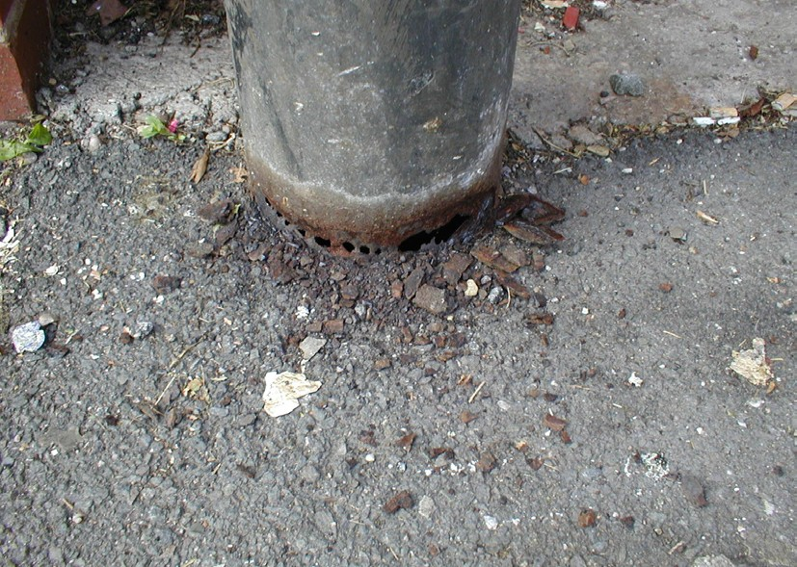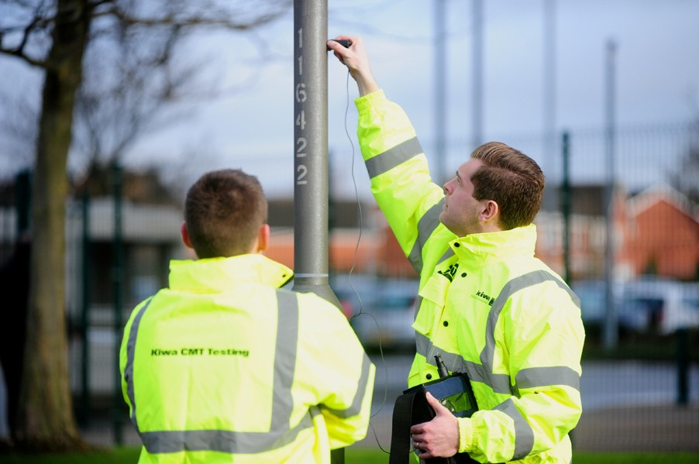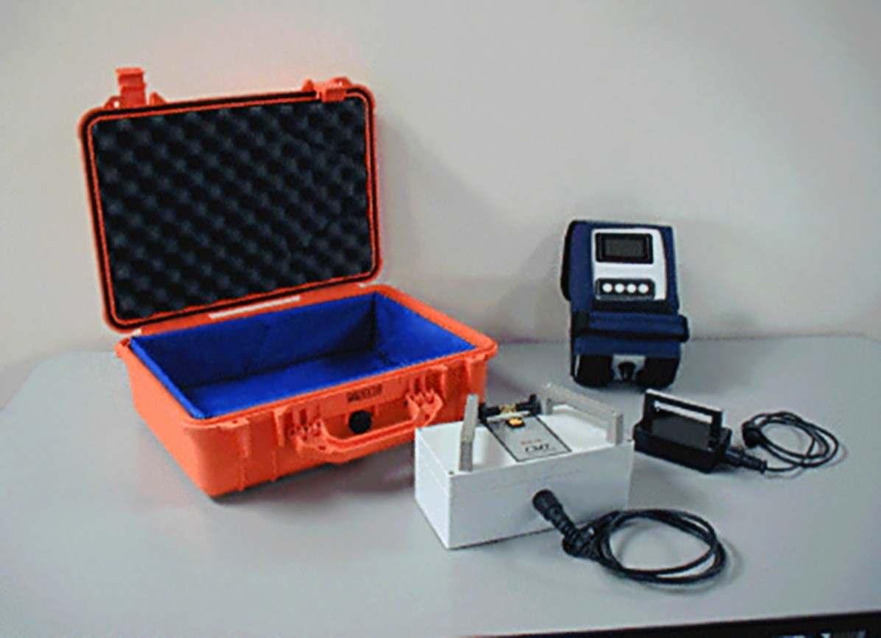Non-Destructive Testing of Lighting Columns

Why Employ Us?
We are a testing company using our own fully trained technicians (no subcontractors) carrying out UKAS accredited testing to ISO 17025 including the use of the unique Relative Loss of Section™ (RLS) system for structural testing of steel lighting columns. A registered organisation under the Highway Electrical Registered Scheme (HERS) for lighting and lit signs and also members of the ILP and HEA.

What we do really matters
Our unique RLS system was developed specifically
to locate and quantify corrosion at the acknowledged key points on steel columns that cannot be identified by visual inspection e.g. below ground (root) internal corrosion of the base and hot-swaged joint.

The technique is a dry-coupled system that provides a cost-efficient assessment of the column.
Results obtained estimate the percentage loss of section allowing the columns to be classified (on a scale of 1-5) for either replacement or periodic re-testing.
Results are provided electronically to enable data to be uploaded into clients inventory.
Cost-effective, on-site inspection and testing services, covering all areas identified in TR22 (Third Edition 2007) as being “at risk”, including:

- Detailed structural inspection (concrete and steel)
- Loss of section monitoring
- Hot swaged joint assessment
- Ultrasonic testing
- Magnetic particle inspection
- Load testing of flange plate bolts
- Assistance with management of other assets

Our accreditation speak for themselves
We care about our clients and strive to give the best service possible. Our unique RLS system was developed in house and resulted in the company becoming the first to be accredited by UKAS for RLS non-destructive testing of lighting columns. Details of tests included in our current schedule can be seen at www.ukas.org.
We are also CHAS accredited and HERS HEA and Constructionline registered so you know you can depend on our credentials.

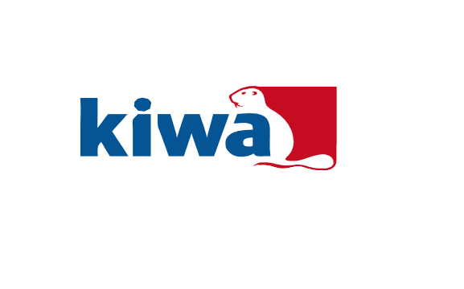
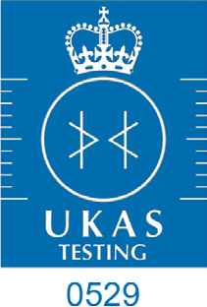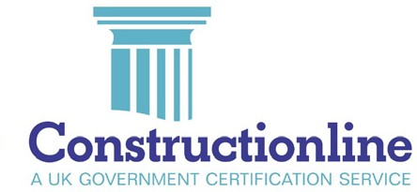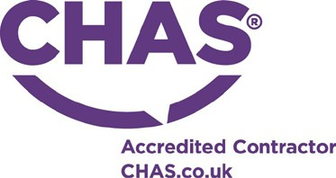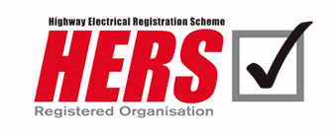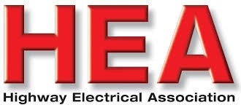

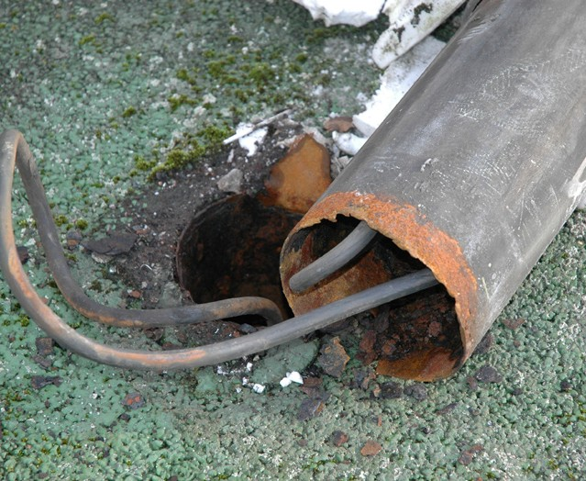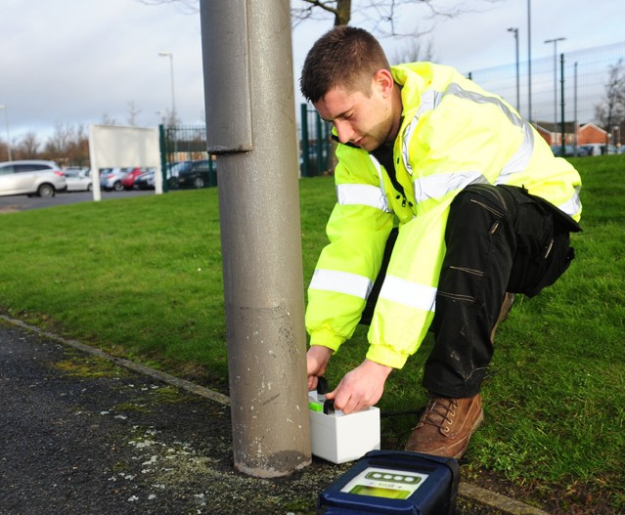Recommended action based on test result:

TR22  Category | Kiwa  CMT  Class | Average LSU’s  (Estimated  % Loss) | Recommendation | TR22-  Priority Score Impact
2U | 5 | -50 | Immediate removal or making safe of the unit | No Change
1U | 4 | -25 to -50 | Schedule for removal/replacement as soon as practicable or in accordance with Operating Authorities Action Matrix | No Change
2G | 3 | -17 to -24 | Re-test within 2 years | Minus 2 from score
3G | 2 | -11 to -16 | Re-test within 3 years | Minus 3 from score
5G | 1 | 0 to -10 | Re-test within 5 years | Minus 5 from score

And don’t forget our other Services:
As an inspection, testing and investigation company with over 40 years of service to the construction, civil engineering, environmental and associated industries, Kiwa CMT Testing provides our clients with a comprehensive scope of laboratory and site testing and investigative operations, under the following headings:

- Geotechnical Investigations
- Lighting Column Testing
- Structural Investigations
- Sports Stadia Barrier Testing
- Contaminated Land
- Offsite Disposal
- 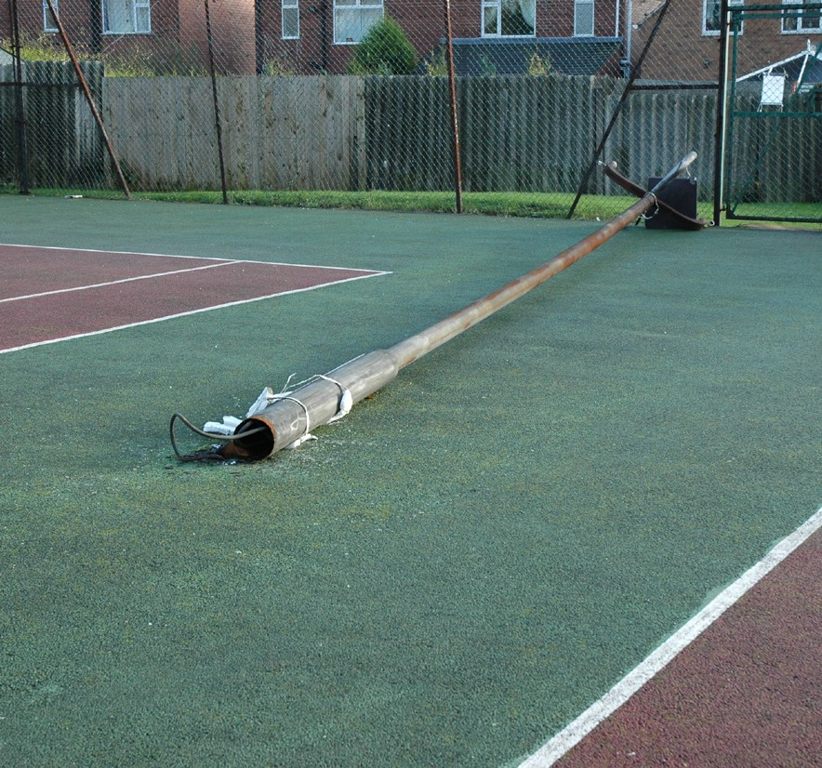Chemical Analysis
- Concrete & Mortar
- Building Products

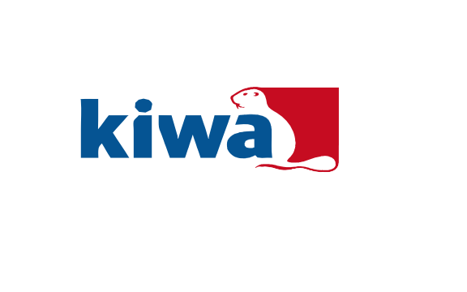
Kiwa CMT
For further information about testing of Lighting Columns or to speak to a member of our Structures Department please contact:

Andrew Sheffield
Structures Manager

T : 01332 383333
E : cmtenquiries@kiwa.co.uk W: www.kiwa.co.uk
Good Advice - Complete Service

