Kiwa UK G3 Unvented certification G3
Form A4 – Primary Application for product certification

This application form is for use by applicants that require a primary certification, secondary certification for already certified unvented packages can be requested by completing the application form A2

The information detailed in this application will be used by Kiwa Watertec to produce your certification documentation and on-line listing subject to a satisfactory application. You must therefore confirm the accuracy of all information provided by signing the application form and any other sections as required.
You are also required to inform Kiwa Watertec of any product amendments or changes that may affect the application or final certification. Failure to do so may invalidate your certification and result in its withdrawal.

It is essential that Kiwa Watertec receives all requested documentation to progress your application:

A completed A4 application form and attached A5 schedule of materials.
(Please ensure you fill in every section indicating ‘not applicable’ if appropriate).
Quality system information e.g., ISO 9001 certificate and scope.
General assembly drawings of the unvented arrangement(s) and detailed drawings of all components relating to the application.
Installation and maintenance documents are required that include scheme specific requirements, for full details contact your project manager.
Photographs of the product and identification marks (This is currently optional).

All applications are subject to the Kiwa Watertec standard terms and conditions.

(Please be aware that failure to include any of the items listed above may result in a delay when processing your application.)

In addition to the above requirements product catalogues, product information manuals and other documentation relating to the product(s) should also be submitted, and any other relevant documentation that may assist in the application process.

* Important * Please be aware that the information detailed in this application will be used by Kiwa Watertec to produce your certification documentation and online listing. It is the responsibility of the certification holder to advise Kiwa Watertec of any changes to the content of this application form. Failure to do so may invalidate the certification and result in it being withdrawn.

 |  | Sample Number  Kiwa use only. | S

Please indicate the type of certification required:
1 | Status of Certification
 | Directly Heated |  | Indirectly heated
 | First application If no state previous approval number:
 | Modification | Additionif yes state the current certification number:
2. | Confirm the current manufacturing status of the product i.e., the product is in production and not a prototype.
 | Production
3. | Name and Address of Applicant.  Unless Kiwa is advised otherwise the applicant (certificate holders) name will be displayed on the certification documentation.
Company name:
Address:

Contact name:
Mobile number:
Email address:
Telephone number:

4. | Contact details of the person responsible for this application if different from section 3
Company name:
Address:

Contact name:
Mobile number:
Email address:
Telephone number:

If you are acting on the applicant’s behalf as an agent, please indicate and ensure you provide a letter of authorisation permitting you to do so with this application.
5. | Name and address of the product manufacturer. If there are more than one manufacturing or assembly sites, please include all site details below.
1: Company name:
Address:
2: Company name:
Address:

Please add additional sites where required:

6. | Communication
Pre-certification:
All contact and/or correspondence should be sent to the person detailed in:
(Please tick as appropriate) section 3 or section 4

Post certification
All certification documentation will be sent electronically for the attention of the contact in:
(Please tick as appropriate) section 3 or section 4

Please note: all correspondence will, by default be sent to the certificate holder detailed in section 3 unless indicated above.
7. | Product name(s) and or model numbers and stated capacities
State all model or product numbers/names/codes that you require to be included in your certification. If there is insufficient space, please provide additional documentation that is clearly marked as an appendix to this application form.
For multiple models/products please explain or list the differences between the models/product

8. | Provide details of the safety devices and package provided with the heating apparatus, including set temperatures and pressures as appropriate.
9. | Detail the marking(s) on the product and include a photograph or illustration of any logo’s  (NB – illustrations and/or photographs may be used on our online database and in the public domain)
10. | Physical samples after test.
Physical samples will be requested for test, to save correspondence later will you please advise Kiwa how we should proceed with samples after test.
For information: samples will automatically be disposed of unless we are formally advised that they will be collected.
Please dispose of samples after approval has been granted
I will arrange collection at our cost within 10 days

Please note all delivery charges, which includes but not restricted to import duty and taxes must be paid by the sender. If Kiwa is invoiced for any charges or fees resulting from samples being sent or any delivery associated with this secondary approval we will change an administration fee where applicable, plus the invoice amount and will be charged to the sender.
*Please note that our administration charge will have a minimum base cost of £100 plus VAT.*

A4 Kiwa UK G3 unvented Declaration
**This must be signed in all circumstances before an application can be processed**

I / We, the Applicant named in section 3 of this form agree that the information provided is accurate.

Signed: …………………………….……………………… Name: ……………………………………….……………
The applicant (Director or other authorised employee/agent of the applicant)

Date: ….………………………………

Important Note: This declaration must be signed by the Applicant or authorised person (agent) duly authorised by completing a letter of authority to act on behalf of the applicant and as detailed in section 4 of this application form.

If further copies of the A4 application form are required these can be obtained via the Kiwa Watertec website.

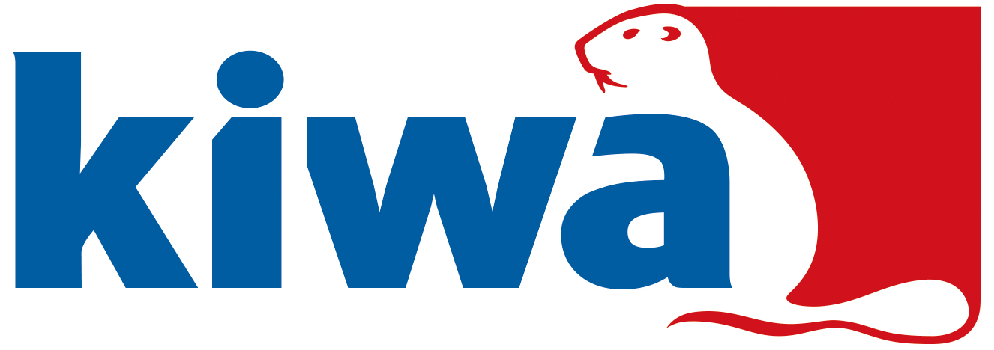
Sample Number | S
Page | of pages

Kiwa Watertec, Form A5 – Schedule of Materials
Important – Please list all parts of the fitting, both metallic, non-metallic and include all lubricants/adhesives/jointing compounds/tapes that are used during assembly and that is in contact with the wholesome (drinking) water. Where a product or component is not in contact with wholesome (drinking) water but may cause waste, misuse, unduly consume or contaminate the water supply these must also be listed.

MODEL numbers/codes: | Drawing Number:

Item number on drawing. | Item description, e.g., seal, O ring, lubricant etc. | Manufacture of material or component. | Tradename & type of material. Include grade, colour and shore hardness e.g. EDPM 123. | BS 6920 report number or KUKreg4 or WRAS approval number. | Process to manufacture item e.g., blow/injection moulded/forged etc.
Signed: ……………………….……………………… Name: ………...……………………………….…………… Date………………………………

