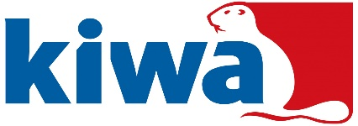
Sample Number  Kiwa use only | S
Page | of pages

Kiwa Watertec, Form A5 – Schedule of Materials
Important – Please list all parts of the fitting, both metallic, non-metallic and include all lubricants/adhesives/jointing compounds/tapes that are used during assembly and that is in contact with the wholesome (drinking) water. Where a product or component is not in contact with wholesome (drinking) water but may cause waste, misuse, unduly consume or contaminate the water supply these must also be listed.

MODEL numbers/codes: | Drawing Number:

Item number on drawing. | Item description, e.g., seal, O ring, lubricant etc. | Manufacture of material or component. | Tradename & type of material. Include grade, colour and shore hardness e.g. EDPM 123. | BS 6920 report number or KUKreg4 or WRAS approval number. | Process to manufacture item e.g., blow/injection moulded/forged etc.
Signed: ……………………….……………………… Name: ………...……………………………….……………… Date………………………………

